# **To complete this activity, follow these steps:**

# Download the [Activity 12.5 Files](https://classroom.emeritus.org/courses/8898/files/2299884/download) folder and ensure that you can open that in VS Code. Provide a screenshot to show that you completed this step successfully.

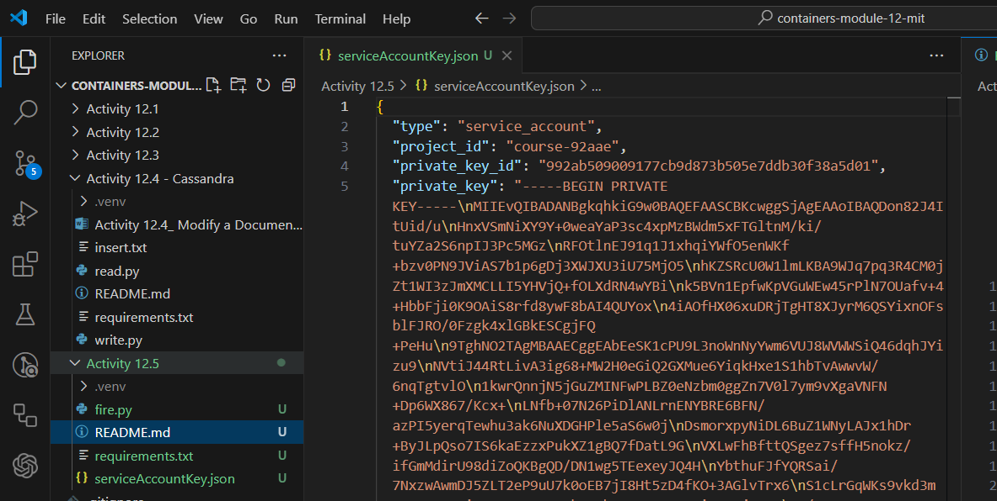

# In your browser, navigate to [Firebase](https://firebase.google.com/) and create a new project called “Activity12-5”. Provide a screenshot to show that you completed this step successfully.

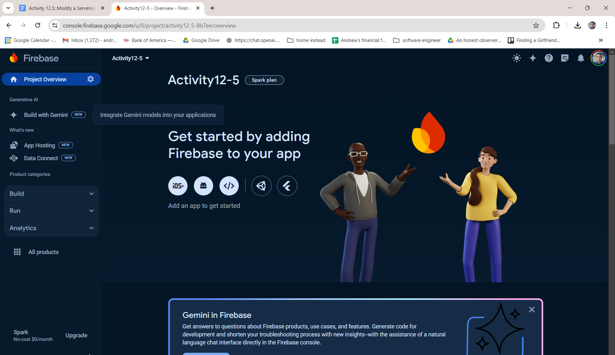

# In Firebase, obtain permissions to write from Python to your database. Download your own private *key* and copy it into the serviceAccountKey.json file in VS Code. For this step, provide two screenshots: One screenshot should show that you navigated to the correct page in Firebase to obtain the private *key*, and one screenshot should show that you copied the file correctly in the serviceAccountKey.json file. Feel free to blur your private *key* in the screenshots.

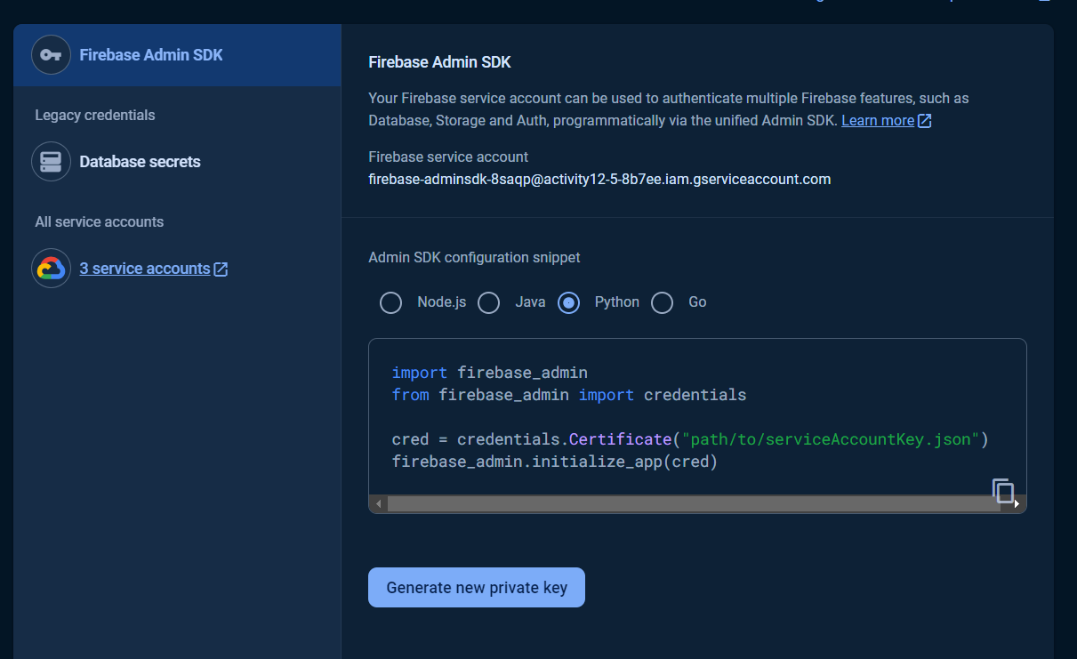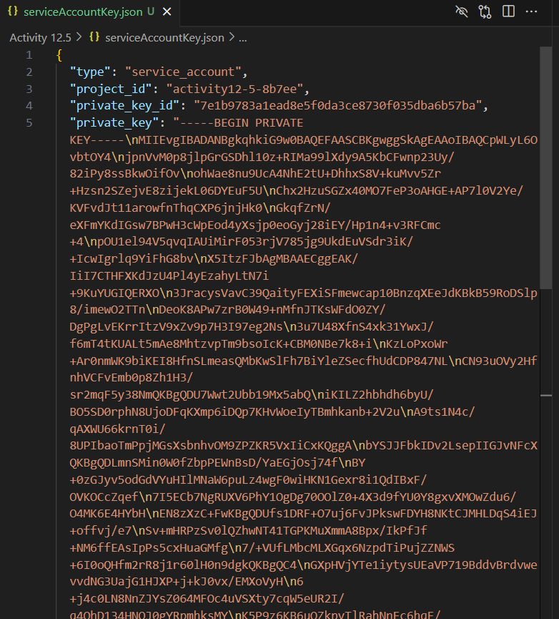

# Create an empty Realtime database for your project in Firebase. Provide a screenshot to show that you completed this step successfully.

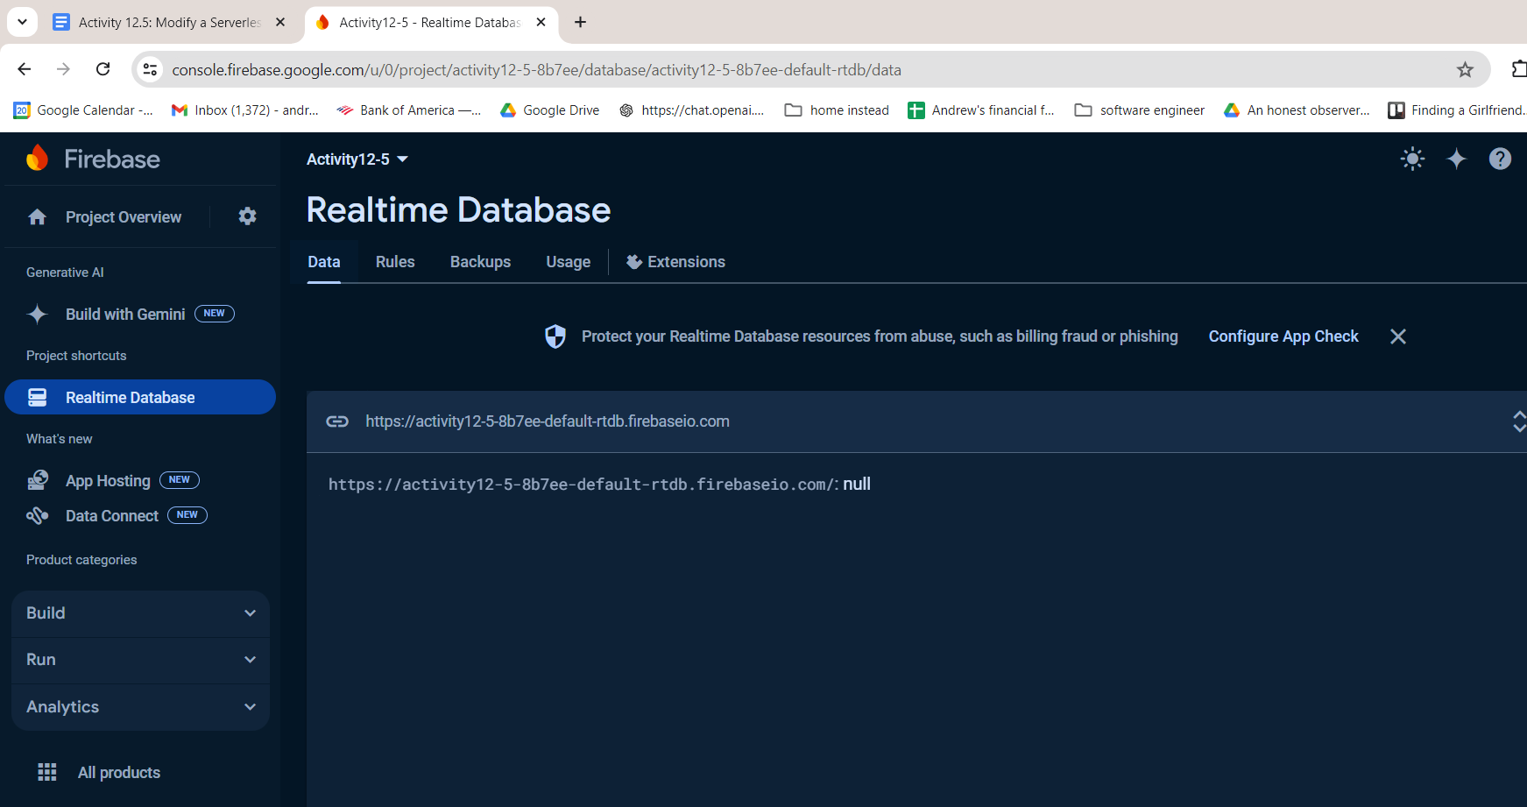

# Open the fire.py file in VS Code. Update the databaseURL field with the URL you copied. Provide a screenshot to show that you completed this step successfully.

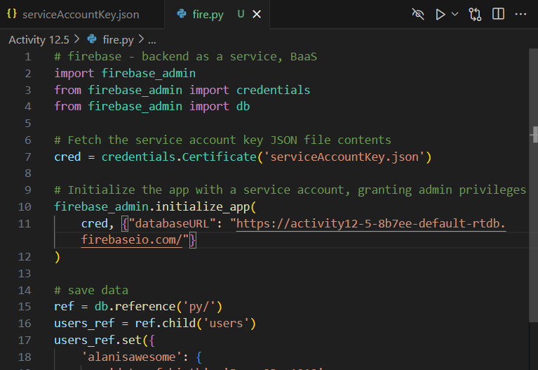

# Edit the fire.py file to update the two entries in your database. You are free to choose these entries as you wish. They can be about anything that interests you. Update the second entry by adding an extra field. Provide a screenshot to show that you completed this step successfully.

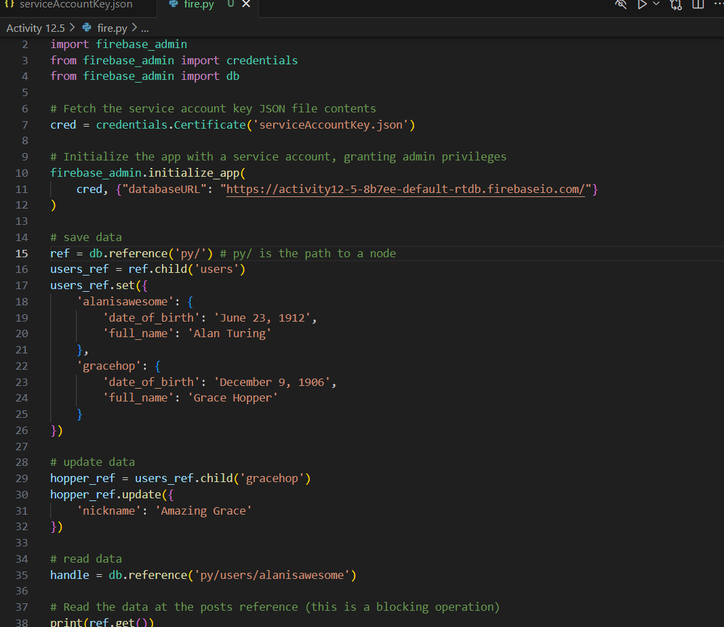

# In a Terminal window, run the correct command to write to your database in Firebase. Provide a screenshot of your Terminal window to show that the command ran without errors.

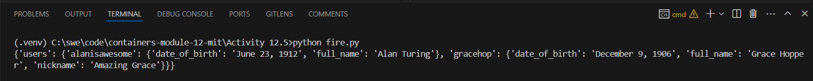

# Provide a screenshot from Firebase to show that your database has been written as expected.

